Eigenvalues and Eigenvector concept
Background
A vector: $\vec{v}$ = $\left(\begin{matrix}1 \\ 3\end{matrix}\right)$

A matrix: A= $\left(\begin{matrix}2 & 1 \\ -1 & 1\end{matrix}\right)$

Question: What happens if we take a vector times with a matrix?

$\vec{y}$ = A$\vec{v}$

$\left(\begin{matrix}1 \\ 3\end{matrix}\right)$* $\left(\begin{matrix}2 & 1 \\ -1 & 1\end{matrix}\right)$ = $\left(\begin{matrix}5 \\ 2\end{matrix}\right)$

Explanation:

$\left(\begin{matrix}1 \\ 3\end{matrix}\right)$*(2 1) = 1*2 +3*1 = 5

$\left(\begin{matrix}1 \\ 3\end{matrix}\right)$*(-1 1) = 1*(-1) + 3*1 = 2

Answer: we have another vector (plot below)

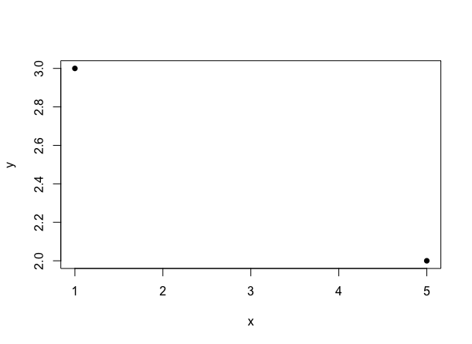
It looks like it ROTATES and THEN STRETCH.

